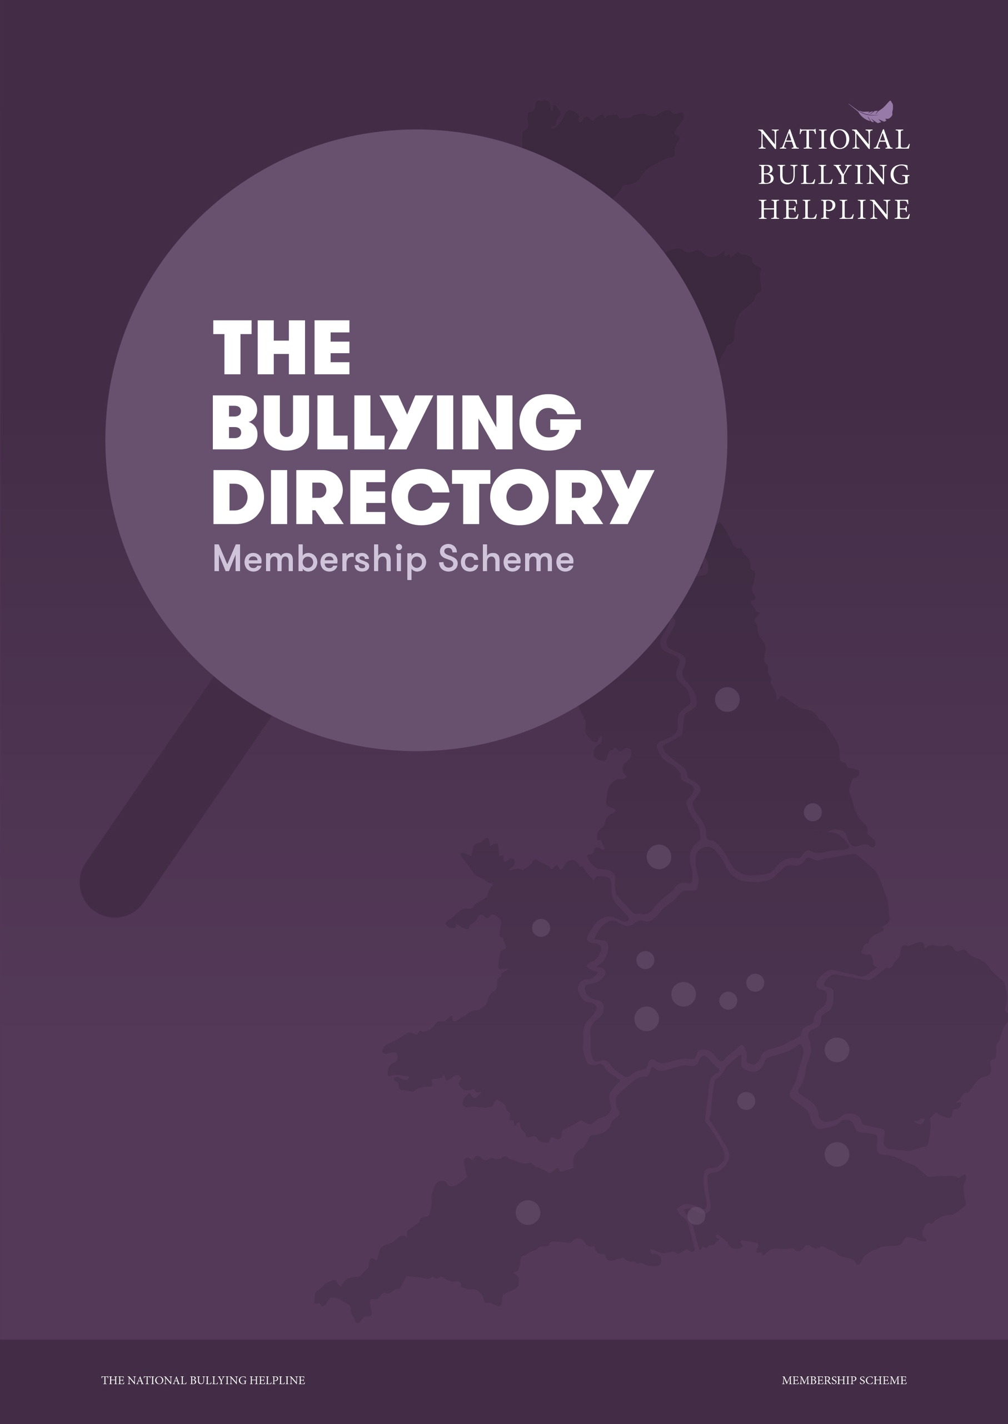

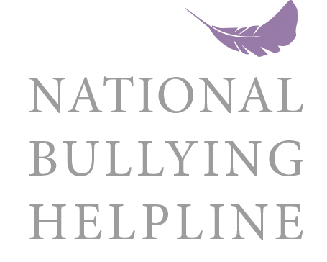

About the National Bullying Helpline

The National Bullying Helpline is a nationally recognised Advice Centre and not for profit charitable organisation dedicated to helping anyone dealing with bullying. Founded in 2003 and established by qualified employment law professionals, we were the first UK helpline to provide assistance to individuals struggling with bullying in the community, the home, school, work or online. Demand for our services has highlighted the need to evolve so we can continue to provide free operational, timely, support to both adults and children.

We are endorsed by The Employment Tribunal Service, ACAS, Citizens Advice, OFSTED, The Samaritans and the NHS. We currently rank number one on Google for Bullying, bullying in the Workplace, Bullying at Work and Bullying at School and find ourselves ranking above ACAS, www.gov.uk, The NHS, Citizens Advice and Wikipedia. We receive hundreds of calls a day from people dealing with the devastating impact of perceived bullying and our website is attracting over 50,000 unique visitors a month.

We work closely with a number of employment law specialists, HR professionals, dispute resolution service providers and local legal firms to offer advice and legal representation where needed. But to be truly effective these professional services need to be accessible across the UK so we can offer our callers options and real solutions locally to them.

The Bullying Directory

The National Bullying Helpline offers free and timely advice to anyone dealing with a bullying related issue. We help businesses and employees understand their rights and the steps they can take to help themselves. Unfortunately, many of our callers find they need more than just advice.

We want to offer our callers professional options and help them to find the right support, whatever that might be. So, we are creating a bullying directory on the National Bullying Helpline website, designed to guide people to local business professionals that offer the services they need.

This is for you if you work in one of the following sectors; Legal, HR, Mediation, Mental Health, Education & Training, Counselling or Coaching, IT cyber-crime support or complimentary dispute-resolution services.

Membership

Become a member of the National Bullying helpline and promote your services to the thousands of people that visit our site every day. Our membership packs offer an opportunity for your business but also enables us to continue our fight against bullying. As a not for profit, Voluntary Organisation, all funds raised from our membership scheme will go directly towards the running of our Free helpline and Website. Our members will be helping us support the Parents and Children that call us every day and also help us invest in local community bullying programmes.

We have 3 membership packs available that offer a presence on our website along with a number of benefits including:

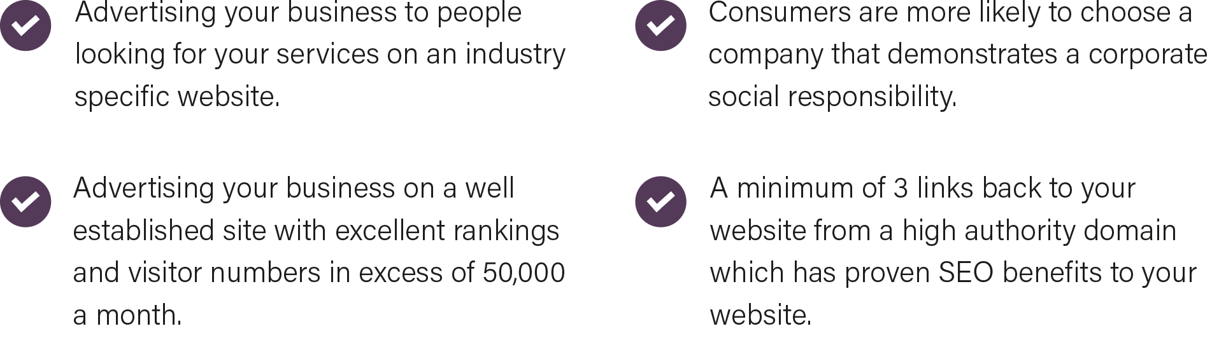

Website Statistics

Below are a few key statistics about the National Bullying Helpline Website.

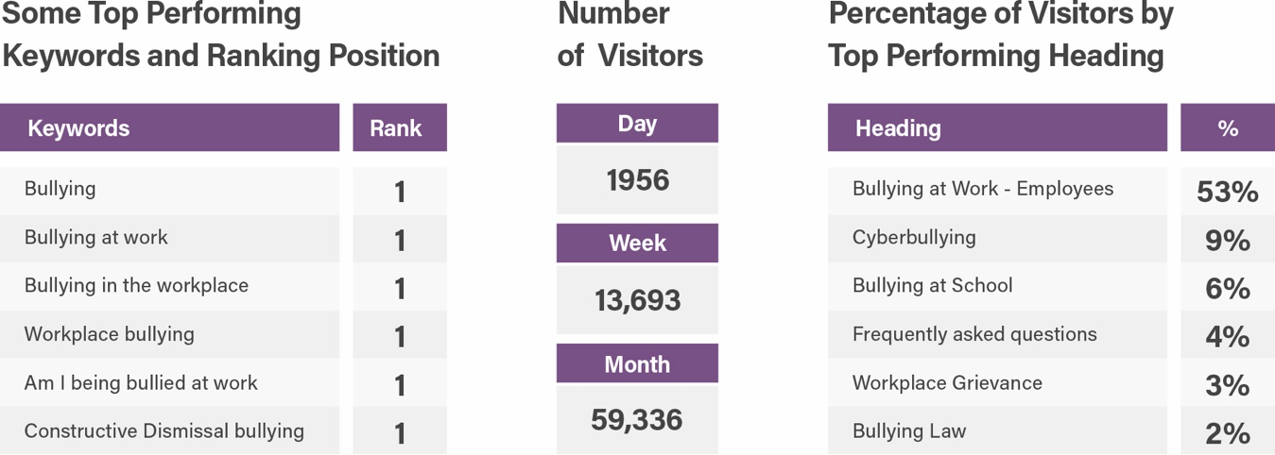

* Statistics and Google Ranking position correct on 22 May 2020. * Some figures have been averaged

Membership Packages

We have 3 membership packages available, Gold, Silver and Bronze. Whatever level of membership you choose and whatever the nature of your business, we believe that by associating with The National Bullying Helpline, you are likely to be viewed favourably in the industry and secure business from this association.

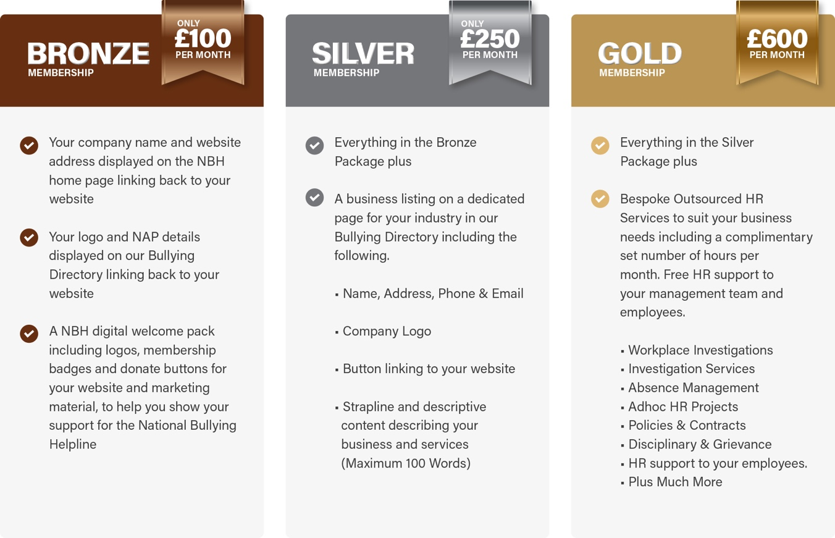

Bronze Membership - £100 per month

This package is ideal for individuals or start-up operations who offer HR consultancy, Coaching, Counselling, Mediation services, cyber bullying services, IT safety services or other conflict resolution complimentary services. An introductory package includes;

- Your company name and website address displayed on the NBH home page linking back to your website

- Your Logo and NAP details (Name, Address & Telephone Number) Displayed on the Bullying Directory linking back to your site.

- NBH digital welcome pack including logos and Artwork for your website and marketing material.

- Permission to advertise the fact that you are a Member of The National Bullying Helpline

- Permission to advertise the fact that you are a Member of The National Bullying Helpline

Silver Membership - £250 per month

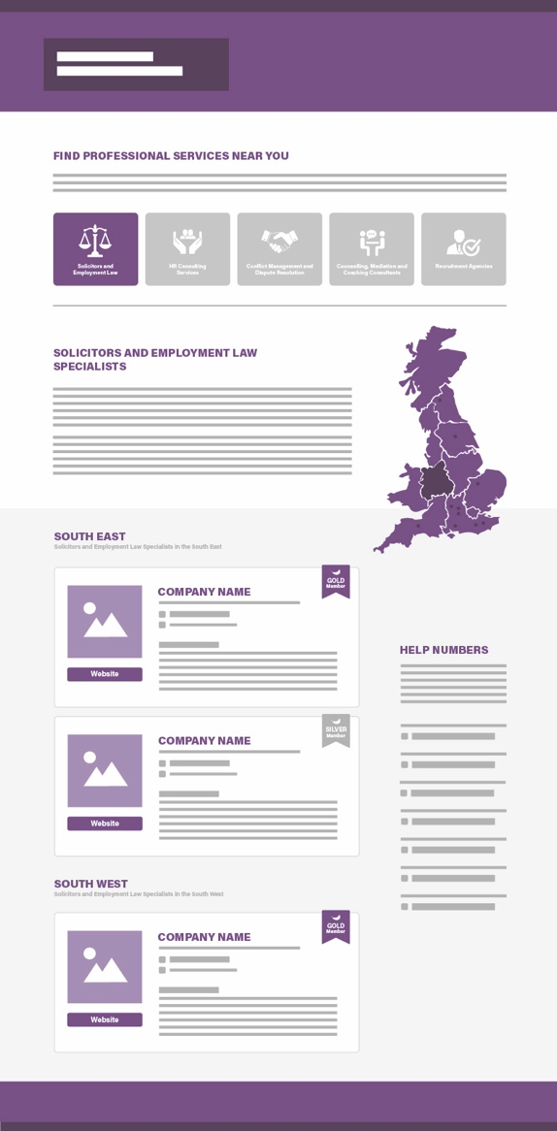
This package is ideal for Corporates or Employers,
Solicitors, Conflict Resolution experts, HR Consultants
and anyone who provides complimentary services
relating to our work. This includes:

- Your company name and website address
displayed on the NBH home page linking
back to your website.

- Your Logo and NAP details (Name, Address &
Telephone Number) Displayed on the Bullying
Directory linking back to your site.

- NBH digital welcome pack including logos and
Artwork for your website and marketing material.

- Permission to advertise the fact that you are a
Member of The National Bullying Helpline.

- A business listing on a dedicated page for your
industry in our Bullying Directory including the
following.
• Name, Address, Telephone & Email
• Company Logo
• Button linking to your website
• Strapline and descriptive content describing your business and services (Maximum 100 Words)

Digital Welcome Pack

Every member will be supplied with a digital pack of National Bullying Helpline Logos and Artwork so you
can show your support for this worthy cause. Recent studies suggest that millennials have driven the social responsibility movement, with 70 percent of them reporting that they’ll spend more with brands that support a good cause.

The Business Listing
Each Business Listing includes Company Logo, Business Name, Address, Telephone Number, Email, Website Link, Headline and Descriptive content (Max 100 Words) and Branch Location (Max 4 Branches)

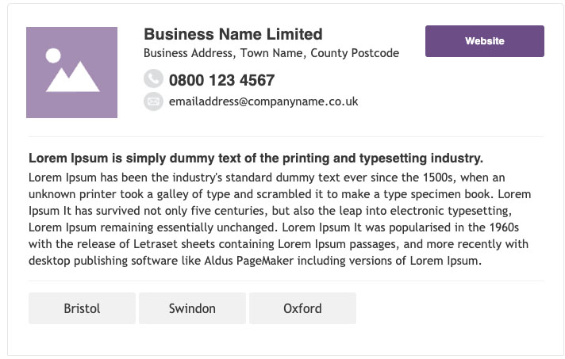

Gold Membership - £600 per month

This package would be ideal for both Public and Private sector employees, for the Corporate employer and
SME’s where there is no HR. We would liken it to an outsourced HR services package. Here you are able to access support for your managers and your employees.

This package includes everything in the Silver Membership and also entitles you to Bespoke Outsourced HR
Services to suit your business needs. This will include a complimentary set number of hours Consultancy per month. We will provide; Free HR support to your management team and employees. This will include (not exclusive) assisting with Change Management and with policy implementation (ie: updating Staff Contracts & Staff Handbook and associated HR policies), advise in contentious cases and/or provide case assessments, provide workplace investigation support-services and a range of other dispute resolution support-services and other adhoc HR services. You will be allocated a qualified HR Consultant in each case.

This is an attractive package for employers who have no HR expertise in-house and/or whose HR teams and business leaders that require additional HR expertise from time to time.

Membership Application Form

Membership Level
Please tick one of the following Gold Silver Bronze

Business Name |  | Business Name
Business Type i.e. Solicitors |  | Business Type
Contact Name and Position |  | Contact Name
Business Address  For businesses with multiple branches that wish to advertise each branch. Please call  0845 22 55 787 |  | Business Address
Telephone |  | Telephone Number
Email |  | Email Address
Website |  | Website URL e.g. https://www.website.co.uk

Gold and Silver Members

Please provide the following information for your business listing

Strapline |  | Your Strapline or Advert Headline
Business Description (100 Words Max) |  | 100 words of content describing your business and services

Branches

Each business listing can display up to 4 Branches with individual links. Please provide details of any branches you want to add to your listing.

Branch Address One |  | Branch Address
Website |  | Website Address

Branch Address Two |  | Branch Address
Website |  | Website Address

Branch Address Three |  | Branch Address
Website |  | Website Address

Branch Address Four |  | Branch Address
Website |  | Website Address

Artwork
Please provide us with a copy of your company logo. Minimum size 150px X 150px

My Logo is attached Please take logo from our website

Terms of Membership & Policy Statement
The National Bullying Helpline is run largely by volunteers. Membership applications are welcomed from businesses or individuals (aged sixteen years or over) with desire to commit and support our work, irrespective of sex, ethnic origin, religion or disability. As a member you are helping us to raise awareness of the support, we are able to provide to the public. Membership does not prohibit you from becoming a Volunteer or from participating in ad-hoc fund-raising activities.

Payment Setup
Please choose a membership package and click the link below to set up your payment. Once we receive confirmation of payment we will start working on your package. You can cancel your subscription at any time with 30 days’ notice.

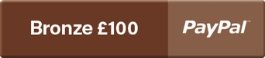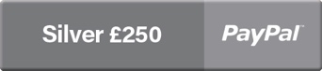

Please consider carefully before signing below
I declare that the information I provide here is accurate and complete to the best of my knowledge and if I am accepted as a member of The National Bullying Helpline, I agree to support the organisation to the best of my abilities and abide by the ethos of the helpline and the requirement of the Directors.

I have completed the payment setup

Signature |  | Your Signature
Date |  | Date

Address your Membership Application to: The National Bullying Helpline PO Box 1276 Swindon SN25 4UX
or Email jamie.dry@nationalbullyinghelpline.co.uk

